1. List the user commands and redirect the output to /tmp/commands.list

history > /tmp/commands.list

2. Count the number of user commands

wc -l /tmp/commands.list

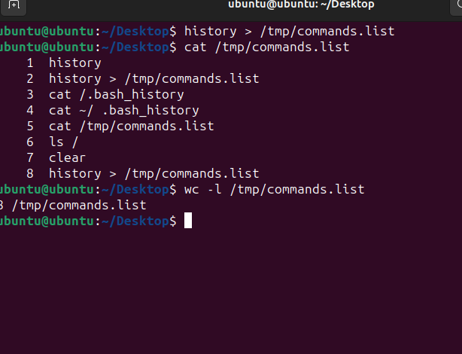

3. Get all the users names whose first character in their login is ‘g’.

cut -f1 -d: /etc/passwd | grep ‘^g’

4. Get the logins name and full names (comment) of logins starts with “g”.

cut -f1,5 -d: /etc/passwd | grep ‘^g’

5. Save the output of the last command sorted by their full names in a file.

cut -f1,5 -d: /etc/passwd | grep ‘^g’ | sort -t: -k2

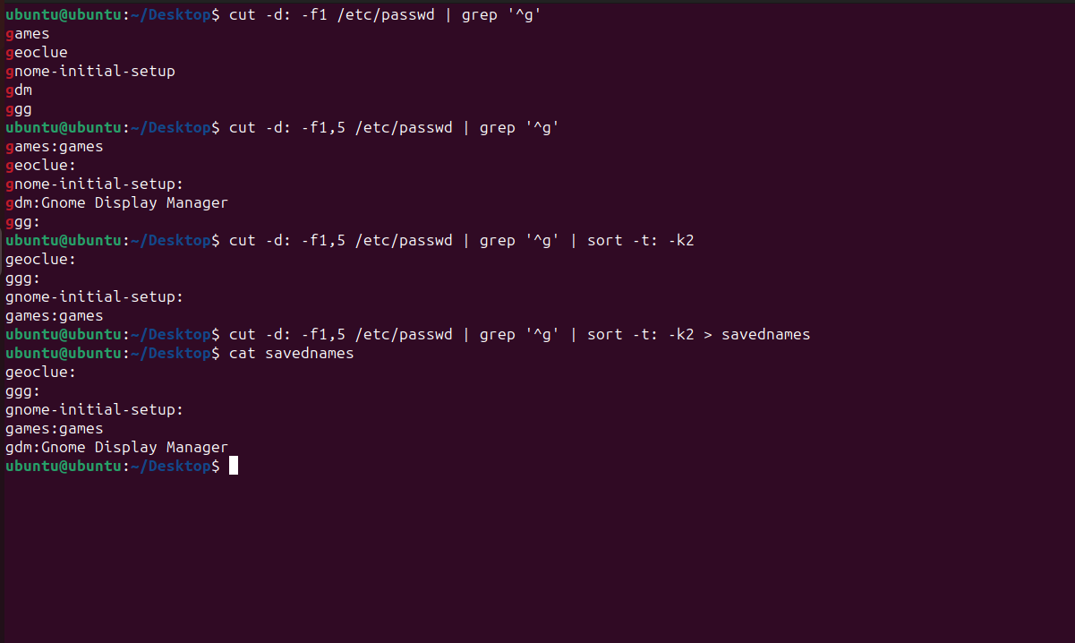

6. Write two commands: first: to search for all files on the system that named .bash_profile. Second: sorts the output of ls command on / recursively, Saving their output and error in 2 different files and sending them to the background.

find / -name .bash_profile > findingsfile 2> /dev/null

ls -R / > listingfile 2> file12 &

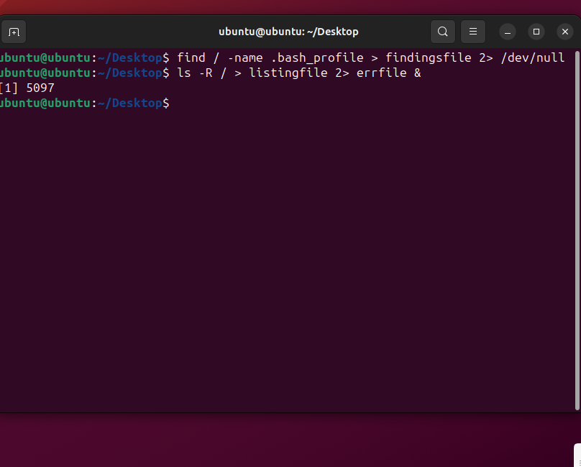

7. Display the number of users who is logged now to the system.

w -h | wc -l

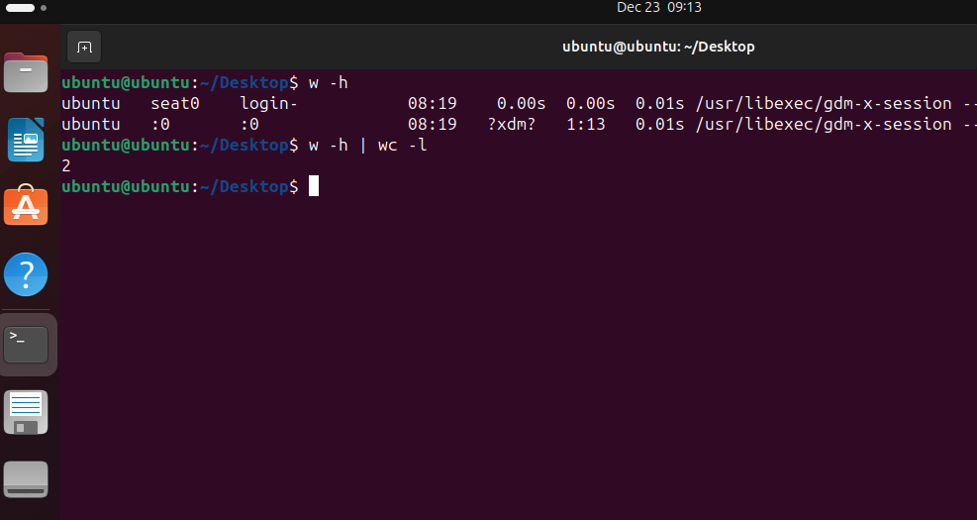

8. Display lines 7 to line 10 of /etc/passwd file

*using sed command that displays lines from a file*

sed -n ‘7,10p’ /etc/passwd file

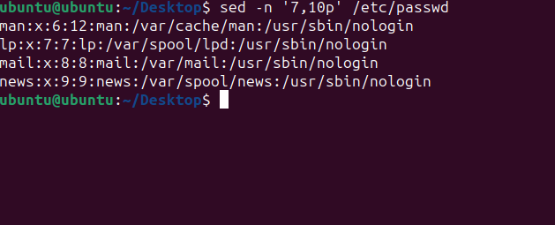

9. What happens if you execute:

* cat filename1 | cat filename2

will show content of filename2

* ls | rm

error

* ls /etc/passwd | wc –l

number of users logged in

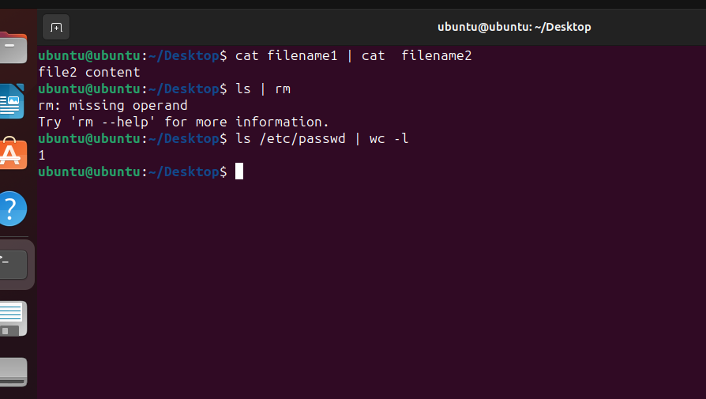

10. Issue the command sleep 100.

sleep 100 &

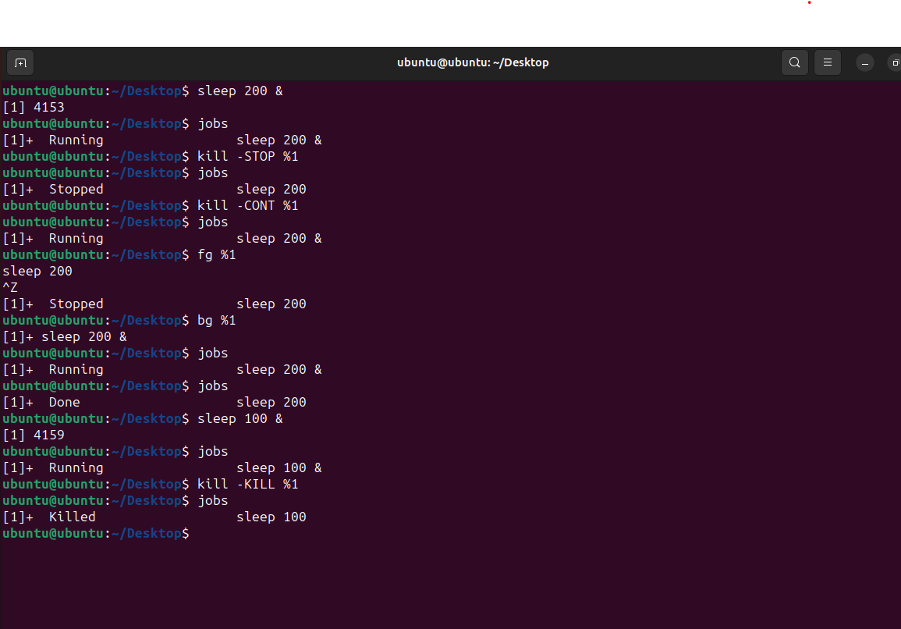

11. Stop the last command.

kill -KILL %1

12. Resume the last command in the background

kill -CONT %1

13. Issue the jobs command and see its output.

jobs

14. Send the sleep command to the foreground and send it again to

the background.

fg %1 to send to foreground

bg %1 to send to background

15. Kill the sleep command.

kill -KILL %1

16. Display your processes only

ps -u 1000

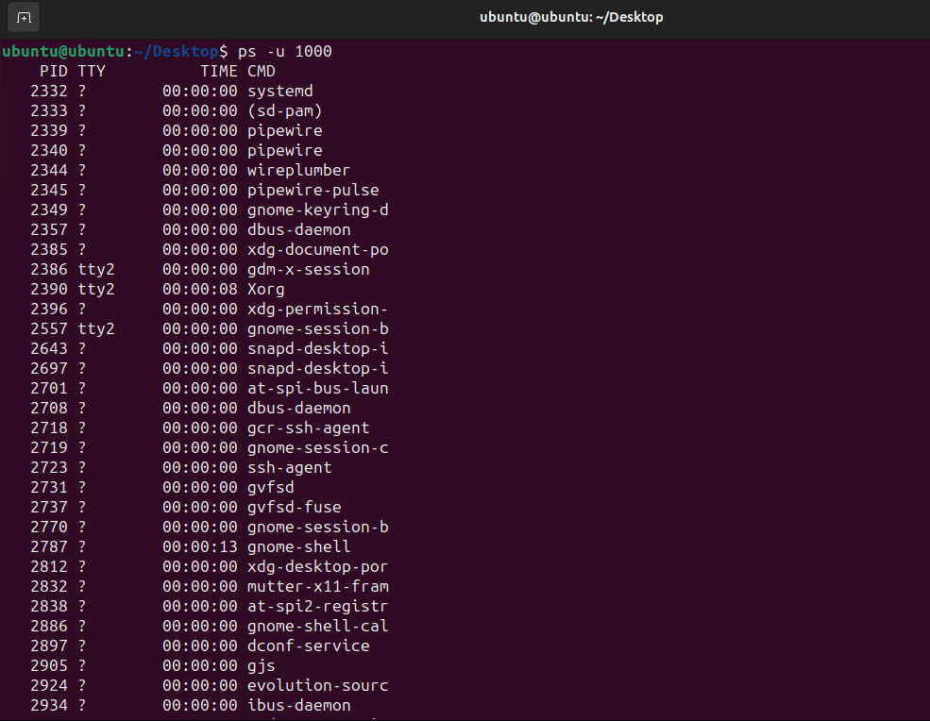

17. Display all processes except yours

ps -f | grep -v ubuntu

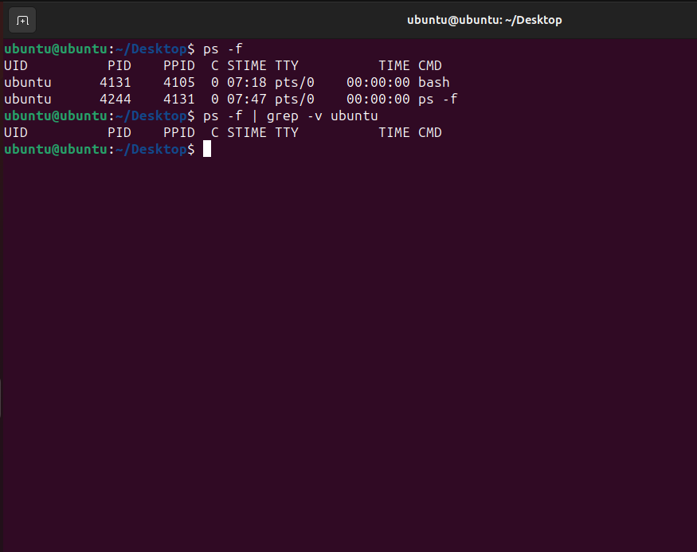

18. Use the pgrep command to list your processes only

pgrep -l -u 1000

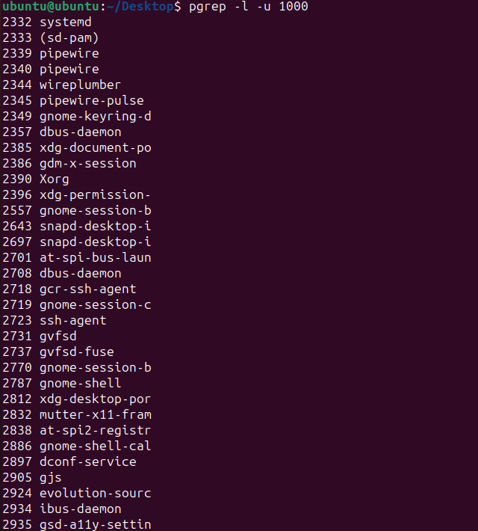

19. Kill your processes only.

killall -u ubuntu